Classis Report - Fall 2023

Climate and Conflict affect our work! July saw the hottest days recorded globally, and it followed the hottest June ever recorded. UN experts predict further temperature records to be broken over the course of the year. This severe weather will likely lead to increased displacement and needs around the world – including more weather-related disasters in the United States. The work of World Renew is essential! Despite these challenges, we continue to have hope and make a profound impact as we work with partners to respond. Thank you for your continued support!!

UKRAINE
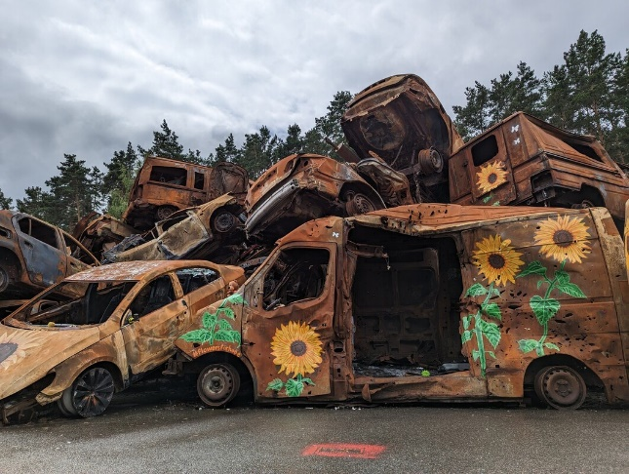
World Renew has been continuing to support the work of partners by providing emergency relief to the numerous displaced people in Ukraine and the surrounding countries. This includes shelter reconstruction, emergency food and medical relief, cash transfers, and winterization support. Two staff members visited Ukraine this summer.
Thanks to our amazing constituents World Renew has been able to raise nearly $3.4 million which has already reached over 585,000 participants in response to the crisis in Ukraine. Over 8,000 participants received cash transfers across multiple projects to promote the local economy amidst the conflict through purchasing from local vendors.
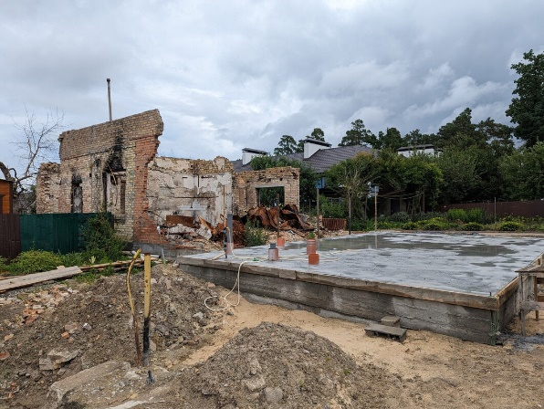
With the destruction of hundreds of thousands of homes across Ukraine, many people require rebuilt of repaired homes. World Renew is collaborating with partners, Integra and ZOA, to provide the most vulnerable households with access to safe housing. This includes winterizing homes, repairing 390 homes, and protecting 1,000 returnees from the destruction of homes and city infrastructures of Chernihiv Oblast with safe emergency shelter interventions helping to reduce the risk of disease and death.
Prayer Request: Russia has recently back out of the Black Sea Grain Deal, a deal that the UN and Türkiye approved allowing safe passage of food transportation to be exported from Ukraine. Many more will go hungry, and prices of food will rise. Please pray for guidance and grace for the leaders involved in the Black Sea Grain Deal.

BANGLADESH
Through our partner SATHI, we are responding to the needs of 175 households affected by Cyclone Mocha with shelter and latrine reconstruction. We are in the third year of a food security program that addresses the needs of 9,331 host community members who have been affected by the influx of Rohingya refugees. We are in the process of extending this project and starting another food security and livelihoods project with partner Faith in Action.

SYRIA
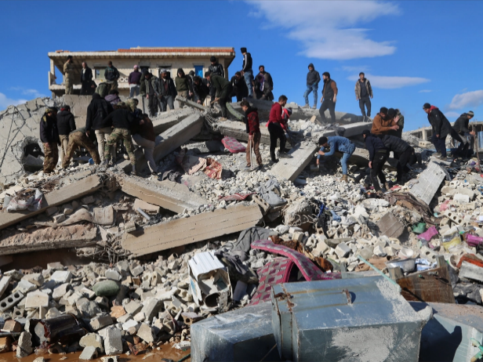
Despite the long-term presence and response, the needs of Syrians have only grown – with the recent earthquake and economic crisis only further magnifying the conflict-related needs. Through local church partners we continue to address the needs of displaced people, providing food, hygiene, and winterization support to over 43,200 highly vulnerable, crisis-affected individuals. The partners reported, “Their voices overflowed with gratitude for the support they received.” With the incredible generosity of World Renew’s supporters, we have been able to commit over $1.5 million USD to the response.

WEST AFRICA
The United Nations Security Council (UNSC) has voted to conclude its peacekeeping mission in Mali following a request from the military government to withdraw the troops. Despite the political and diplomatic tension between the current military transitional authorities and the UNSC, the Malian government and humanitarian organizations are urging for heightened international support to address the escalating crisis.

Prayer Request: We are closely monitoring and praying for the instability and recent coup in Niger. All staff are safe. We pray for peaceful resolution that is best for the people of Niger.

NORTH AMERICA: Disaster Response
Over the summer DRS has worked on Needs Assessments in multiple Florida counties and hosted groups in Florida, Kentucky, West Virginia, Detroit, Michigan, and North Carolina. World Renew is closely monitoring the situation in Hawaii. We are holding the communities affected in prayer and discernment but are not launching a fundraising effort at this time. World Renew will continue to watch closely, connect with local partners, and join Fema related updates and discern how or when we will move forward.

Fall Volunteer Opportunities: Managed Reconstruction Sites: Contact Diana, 616-224-0701.
- Whatcom County, Washington, Boutte, Louisiana, Sarasota, FL

Group Trips: Contact Chris at cgibson@worldrenew.net.
- Southwest Florida & Daytona, Florida, Rolling Fork, Mississippi, Detroit, Michigan, Madisonville, Kentucky, Paradise, California, New Bern, North Carolina, Whatcom County, Washington
Refugee Sponsorship and Resettlement Program (RSRP) reports summer 2023 saw 42 refugees sponsored; 63 refugees who have arrived. The RSRP team is currently working with 69 CRCs and 52 churches from other denominations (waiting for refugees to arrive, currently resettling newcomers, currently working on refugee sponsorship applications to be submitted in 2023; these activities may extend over several years); 375 refugees who have applications submitted with the RSRP and who are waiting to arrive.

Global Engagement Learning Opportunities
Join a Look, Listen and Learn Trip: globalvolunteers@worldrenew.net
October 28 – November 6 – Malawi and Zambia – Look, Listen and Learn
April 22-27 – Lebanon. – Look, Listen and Learn
November 2024 – Cambodia – Look, Listen and Learn
July 2024 – Guatemala “Equipped to Educate” Educators Learning Tour

Fall Offerings: November 5 – World Hunger Sunday

For general information contact - Iona Buisman (ibuisman@worldrenew.ca)
Church and Community Engagement Canada

